**TUGAS MANDIRI**

NAMA: FIKAR DWI RAMADHANI

NIM: 24.240.0022

KELAS: 1P42

Soal:

1

1 1 1

1 1 1 1

1 1 1 1 1

Total =…….

2

2 2 2

2 2 2 2

2 2 2 2 2

Total =…….

3

3 3 3

3 3 3 3

3 3 3 3 3

Total =…….

Total Keseluruhan =…….

Analisa Program:

**CI = 1**

1

5

3

4

2

1

1 1 1

4

3

2

1

1 1 1 1

1

3

2

1

1 1 1 1 1

Total =…….

**CK = 1**

**CK = CK + 1**

**TOTAL = 0**

**TOTAL = TOTAL + CK**

2

2 2 2

2 2 2 2

2 2 2 2 2

Total =…….

3

3 3 3

3 3 3 3

3 3 3 3 3

Total =…….

**CI <= 3**

Total Keseluruhan =…….

**GT = 0**

**GT = GT + TOTAL**

Program:

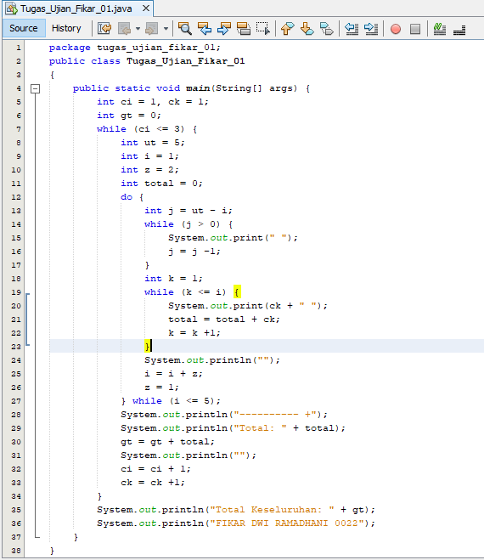

Run:

